

Sri Lanka’s Leading Hoteliers Celebrate 20 Years of Purpose-Driven Hospitality
2025 Marks 40 Years of Dilmah Tea and 20 Years of Ceylon Tea Trails

- To mark the occasion, the brand has launched an upgraded journey through ‘Tea, Sea & Safari’ uncovering the best of the island’s tea country, southern coastline, and wild jungles
- Looking ahead, the team will continue to pave the way in ethically minded hospitality with three new openings slated for the next few years

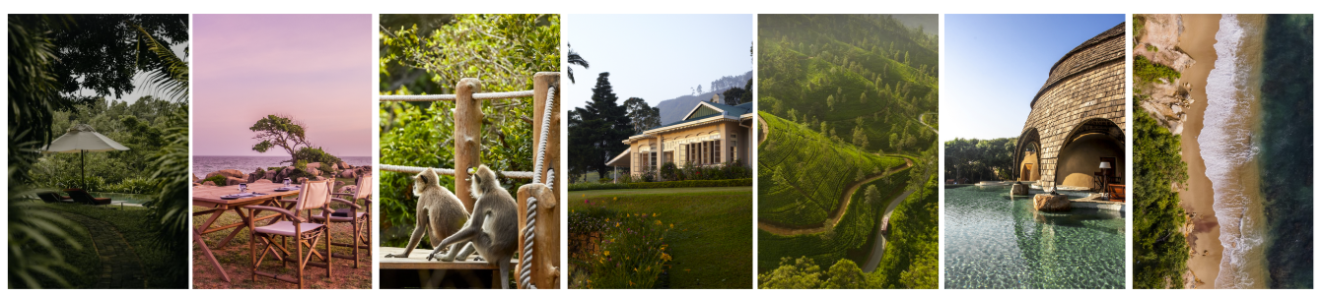

Friday 8th August 2025 | London: Resplendent Ceylon, Sri Lanka’s leading luxury hospitality brand, proudly marks its 20th anniversary this year, coinciding with 40 years of mother brand, Dilmah Tea, the iconic and ethical tea company founded by Merrill J. Fernando. These two parallel legacies share a philosophy rooted in excellence, authenticity and a deep pride in Sri Lankan heritage.

Since launching Ceylon Tea Trails in 2005 as the world’s first tea bungalow resort on a working estate, Resplendent Ceylon has consistently set the benchmark for experiential travel across the island. Its unique circuit of boutique resorts now includes Wild Coast Tented Lodge in Yala and Cape Weligama on the southern coast, offering travellers a distinctive journey through tea country, jungle wilderness and coastal charm.

In celebration of this milestone, Resplendent Ceylon has curated a ‘Tea, Sea and Safari’ 10-night journey across all three of its award-winning properties. This itinerary has been designed to offer guests a once-in-a-lifetime experience that encapsulates the spirit of Sri Lanka’s landscapes, culture, and warm hospitality.

Highlights of the anniversary journey include a private tea tasting hosted by Resident Planter at Dunkeld Estate in Hatton, a scenic helicopter transfer to the Elephant Transit Home near Yala, a full day guided safari experience, and an immersive Southern Riviera culinary adventure at Cape Weligama. Guests will also receive bespoke memorabilia including a limited-edition commissioned painting, an engraved anniversary badge and a personalised Dilmah tea collection with signed editions of three iconic Sri Lankan books.

Looking ahead, Resplendent Ceylon remains committed to responsible expansion. Upcoming properties include Canopy Lodge in Sigiriya, located near the island’s ancient cultural triangle, and Kelburne Estate in the cool hills of Haputale. These developments will further the brand’s vision of meaningful, purposeful travel rooted in community engagement and environmental stewardship.

Commenting on the anniversary, Malik J. Fernando, Chairman and Managing Director of Resplendent Ceylon and son of Dilmah founder Merrill J. Fernando, said: “Sri Lanka is a small island, but one of immense richness. Tourism can play a vital role in supporting our economy and sharing our unique story with the world. At Resplendent Ceylon, we are committed to thoughtful growth, ensuring that purpose, community and authenticity remain at the core of everything we do.”

Guided by the Dilmah philosophy of business as a matter of human service, Resplendent Ceylon’s operations continue to be underpinned by local collaboration, environmental responsibility, and a deep focus on social upliftment. The brand continues to redefine luxury as an enriching, meaningful experience for both guests and the island nation. As Resplendent Ceylon marks two decades of innovation and impact, it reaffirms its mission to raise the bar for sustainable luxury travel in Sri Lanka and to position the island as a world-class destination of culture, beauty, and soul.

To book: Resplendent Ceylon’s ‘Tea, Sea & Safari” journey starts at USD 20,000. This includes a 10-night stay across all three Resplendent resorts, Ceylon Tea Trails, Wild Coast Tented Lodge, and Cape Weligama on a fully Inclusive basis. For more information, please visit: resplendentceylon.com

Images: HERE

For media enquiries and images, please contact BIRD; resplendentceylon@birdtravelpr.com

- ends -
Notes to Editors
Resplendent Ceylon
Set up by the Fernando family — founders of Dilmah, Sri Lanka’s foremost tea brand — Resplendent Ceylon was formed to create and manage a number of small, luxury resorts, tracing a unique trail across Sri Lanka. Ceylon Tea Trails, a collection of five luxurious and historic bungalows and a private one-bedroom cottage set amidst 2,000 acres of lush tea plantation, opened in 2005 as the world’s first tea bungalow resort. Sister resort Cape Weligama opened on a soaring south coast clifftop site, overlooking the Indian Ocean, in 2014, offering 39 spacious and sumptuous villas and suites. Wild Coast Tented Lodge, the third resort in the collection, opened in November 2017 on a secluded beachfront site on the edge of Yala National Park, fusing the excitement of a safari camp with the comforts of a luxury hotel through 28 luxurious tented suites. In February 2023, the Resplendent Ceylon team launched a new brand under the name of Reverie - a collection of laid-back boutique properties which embrace the slow pace of life that the island embodies. The group debuted with the opening of Kayaam House in Tangalle, and Ahu Bay in Ahungalla.

MJF Foundation
The MJF Foundation, set up by Dilmah Tea, has changed the lives of over 100,000 underprivileged Sri Lankans. The Foundation has awarded over 250 educational scholarships to members of the tea making families, provided livelihood assistance to 1,008 families, supported over 220 individuals through the small entrepreneur Programme and provided holistic development programmes for children across the island. To date, over 150 differently-abled children have been provided with special education, therapy and training through the Foundation’s work.

